**Experiment no 8**

**Aim: To implement list in prolog**

1. **Program to perform Sum of list**

Program:

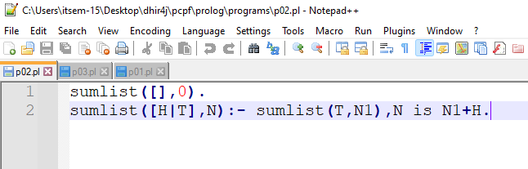

Output:

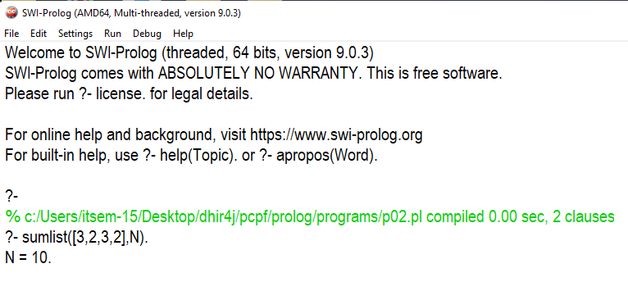

1. **Program to get Size of list**

Program:

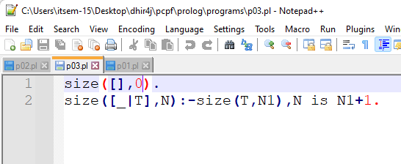

Output:

